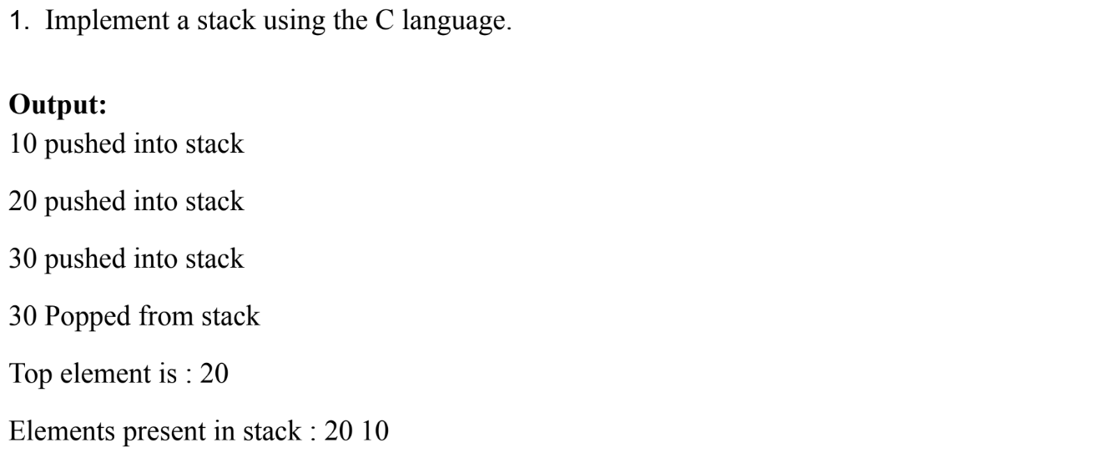

#include <stdio.h>

int stack[4];

int Maxstk=4;

int Top=0;

int push(int value)

{if(value==Maxstk)

{printf("Overflow"); }

else{Top++;

stack[Top]=value;

return value; }}

int pop(int value)

{if (Top==0){

printf ("Underflow"); }

else{value=stack[Top];

Top--;

return value; }}

void main()

{ printf("%d pushed into stack\n",push(10));

printf("%d pushed into stack\n",push(20));

printf("%d pushed into stack\n",push(30));

printf("%d popped from stack\n",pop (30));

printf("Top element is %d\n",stack[Top]);

printf("Element present in stack:");

for(int i= Top; i>0; i--){

printf("%d ",stack[i]); }}

**Output:**

10 pushed into stack

20 pushed into stack

30 pushed into stack

30 popped from stack

Top element is 20

Element present in stack:20 10

**1**

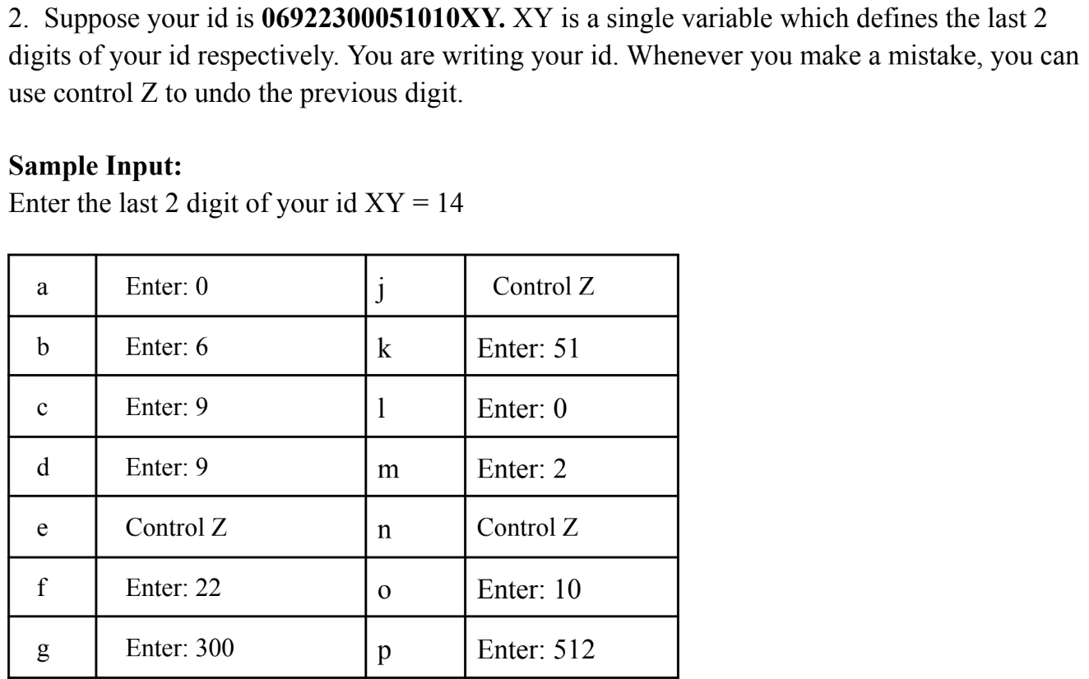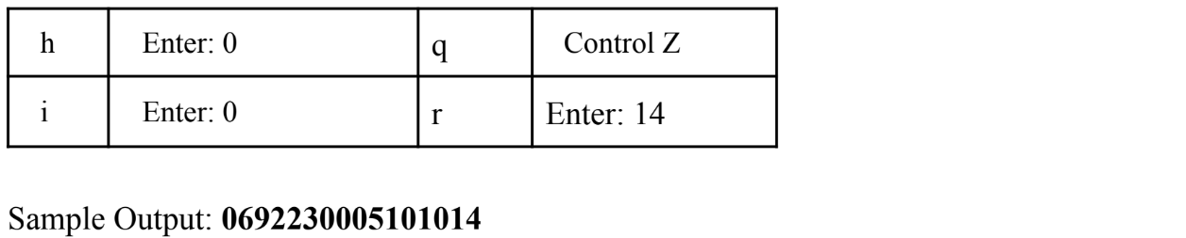

#include<stdio.h>

int MAXSTK=16;

int stack[16];

int top=0;

int push(int item)

{ if(top==MAXSTK)

{ printf("The stack is already filled");

return 0;}

else{top=top+1;

stack[top]=item;

printf("Enter:%d\n",item);}}

int pop(int item)

{ if(top==-1){

printf("Stack is empty");

return 0; }

else

{ top=top-1;

printf("Control Z\n",item);}}

int main()

{ int p,XY;

printf("Enter the last two digit of your id XY=");

scanf("%d",&XY);

push(0);push(6);push(9);push(9);pop(9);push(22);push(300);push(0);push(0);pop(0);push(51);push(0);push(2);

pop(2);push(10);push(512);pop(512);push(XY);for(p=1;p<=top;p++)

printf("%d",stack[p]);}

**2**

**Output:**

Enter the last two digit of your id XY=14

Enter:0

Enter:6

Enter:9

Enter:9

Control Z

Enter:22

Enter:300

Enter:0

Enter:0

Control Z

Enter:51

Enter:0

Enter:2

Control Z

Enter:10

Enter:512

Control Z

Enter:14

0692230005101014

**3**

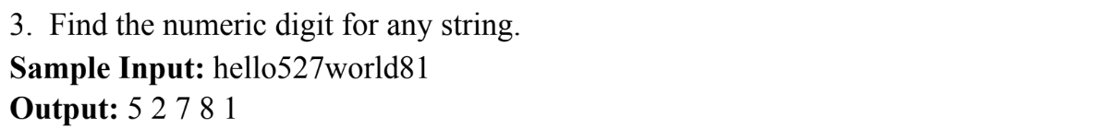

#include <stdio.h>

int main() {

char input[100];

printf("Enter a string: ");

scanf("%s", input);

printf("Numeric digits in the string: ");

for (int i = 0; input[i] != '\0'; i++) {

if (input[i] >= '0' && input[i] <= '9') {

printf("%c ", input[i]); } }

printf("\n");

return 0;}

**Output:**

Enter a string: hello527world81

Numeric digits in the string: 5 2 7 8 1

**4**